To: Dr. David Mitchell
Director of Education, Atlanta Institute of Music and Media

From: Laura Frost, Crime Analyst II, Gwinnet County Police Department

Date: May 13, 2024

Subject: Clery Act

In reference to your request for information in compliance with the Clery Act, all statistics were pulled. The statistics were pulled utilizing Arc GIS Pro and Live CAD (computer aided dispatch) calls. For this request, the address was drawn around to capture the crimes reported to our department in 2023, 2022, and 2021 for 2875 Breckinridge Blvd, Duluth. There were no incidents for those years requested.

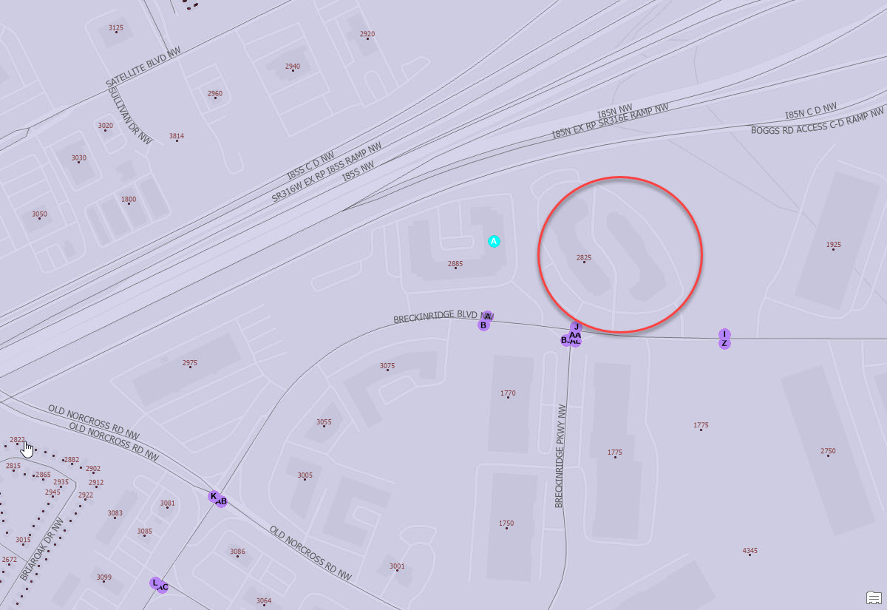

If you need any further assistance, please contact me 770-513-5229.

Laura Frost

